**Birdie,** By Peter Davis, G1MRA #257. August 2023

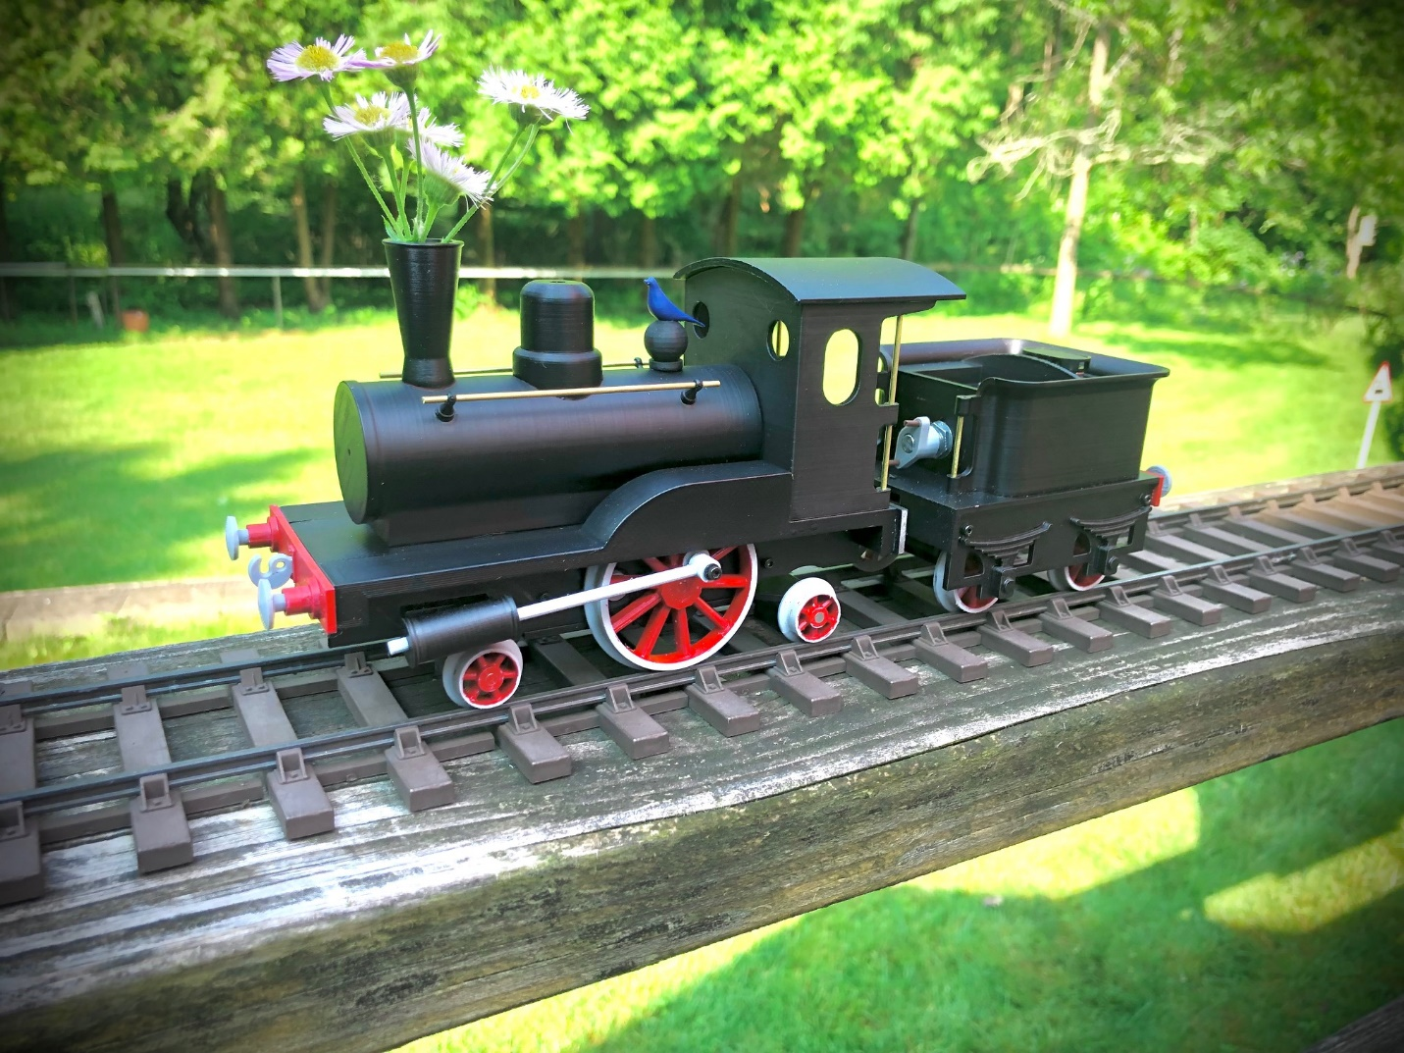

This is a freelance copy of a photo I saw and liked, nick named “Storkleg”, a model steam toy of around 1900. Here sized 1:1 and to run on 45mm gauge track. Importing the photo into my drafting program, I scaled the driver to 45mm diameter, then took other measurements where I could, estimating the rest. Printed parts were done with .4 Nozzle on a Creality Ender 3-S1 using Duramic PLA+ filament. The coach, of no particular model, I also freelanced

Purchased parts include a N-20 geared motor 6V, 300 rpm, a DC low voltage speed controller, A 9V battery clip and 9V battery. (I used a rechargeable 9 v battery I had on hand). Also I purchased an assortment of M2 screws 4 to 16 mm length and 3mm ground steel rod. All from Amazon. From local hobby store, K&S .45mm wall brass tube 4mm and 3mm OD. 1.5mm Brass rod for hand rails.

The 9V battery stands upright in the tender. Ease to remove for replacement or recharging. The snap connector looks to be the water tank filler.

It will run from a crawl to a nice speed at half throttle, pulling (easily) 2 of its coaches on a 20” radius circle of track. Mine has no reverse, but could be added.

**Part 1, Dive-Motor.**

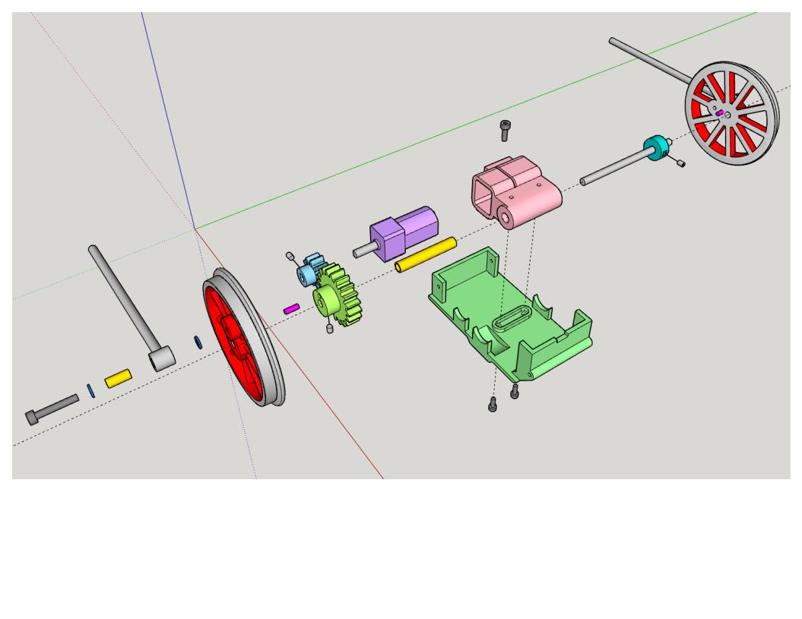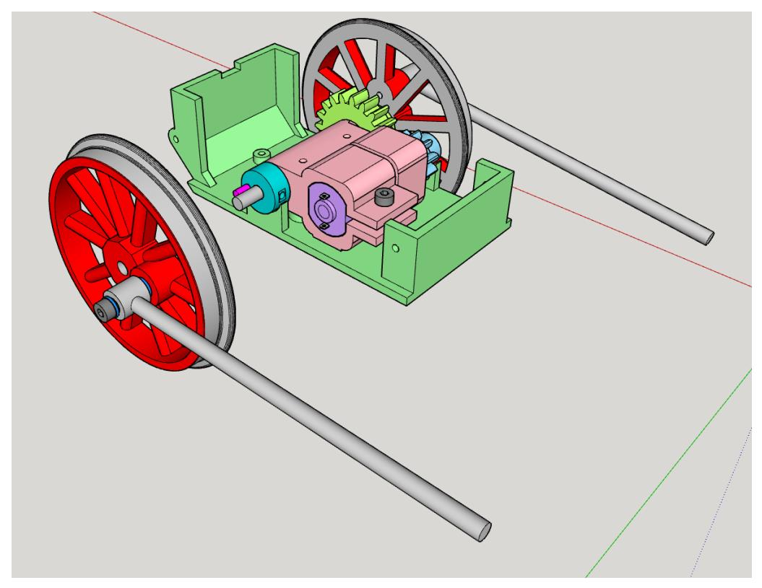

1. N-20 Pan: Print with support touching buildplate. Tap the bottom rear and 4 side holes M2.

1. Motor Hsg: Tap holes M2. Uses a 4mm OD X .45mm wall X 25mm length of K&S brass tubing for drive axle bearing. 3MM ground rod 52mm long drive axle.
2. Spacer: Tap set (grub) screw hole M2.
3. 10T gear: Tap set (grub) screw hole M2.
4. 20T gear: Tap set (grub) screw hole M2.

06.0 Wheel 45mm: Tap the crank pin hole M2. The axle ends should be flush with the wheel face.

07.0 Piston Rod: Mounts to wheel with M2 x 16mm long screw thru a 3mm OD X .45mm wall X 7MM long K&S brass tube with small washer on each end.

**Part 2, Footplate.**

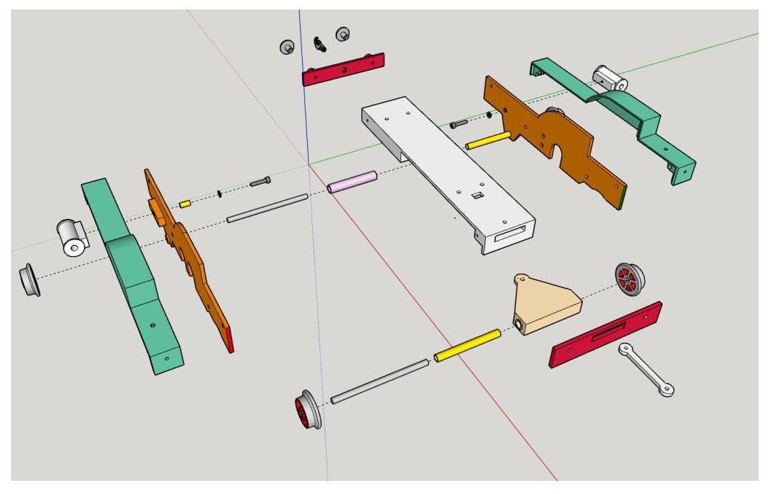

08.0 Footplate: Print with 100 percent infill. (For extra weight). Tap the 4 side holes M2

09.0 Frames Left & Right: Fit a 5mm length of 3mm OD X .45mm wall brass tube into the cylinder pivot hole.

10.0 Fenders Left and Right: Tap the rear hole in each side M2.

11.0 Cylinder: Tap the pivot hole M2

12.0 Drag Beam

13.0 Buffer Beam

14.0 Front Axle: Fit with a 4mm OD X .45mm wall X 39mm long brass tube.

15.0 Wheel 15mm: Front and rear are alike. Fit with 3mm ground rod 53mm long.

16.0 Rear Truck: Fit with a 4mm OD X .45mm wall X 39mm long brass tube. Attaches to the Motor Pan with M2 screw. Allow for side and up down movement.

17.0 Draw Bar. Use short length of filament as pins.

18.0 Hook

19.0 Buffer: Tap M2. You will have to temporarily remove the screw holding the frame to the foot plate to install this screw.

**Pare 3, Boiler.**

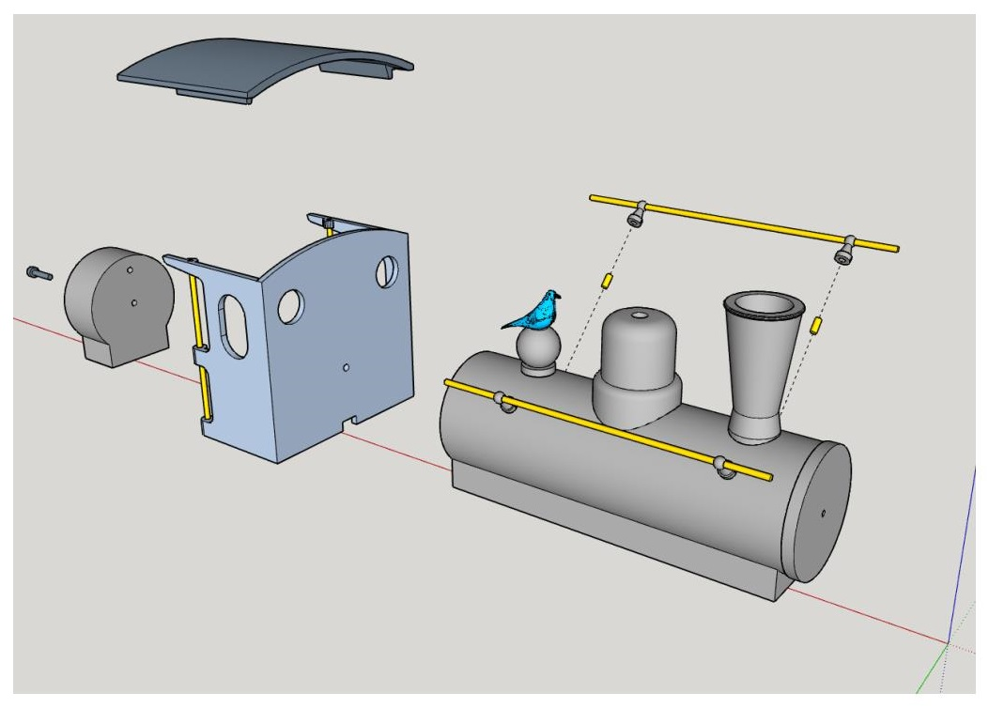

20.0 Boiler: printing vertically, Smokebox end up. Tap the holes M2. Filler dome has no tapped hole.

21.0 Chimney

22.0 Dome

23.0 Handrail Knob: Mount with glue and a small length of 1.5mm brass rod.

24.0 Filler Dome

25.0 Cab: Tap holes M2.

26.0 Roof: Glue in place.

27.0 Birdie Plate

**Part 4, Tender.**

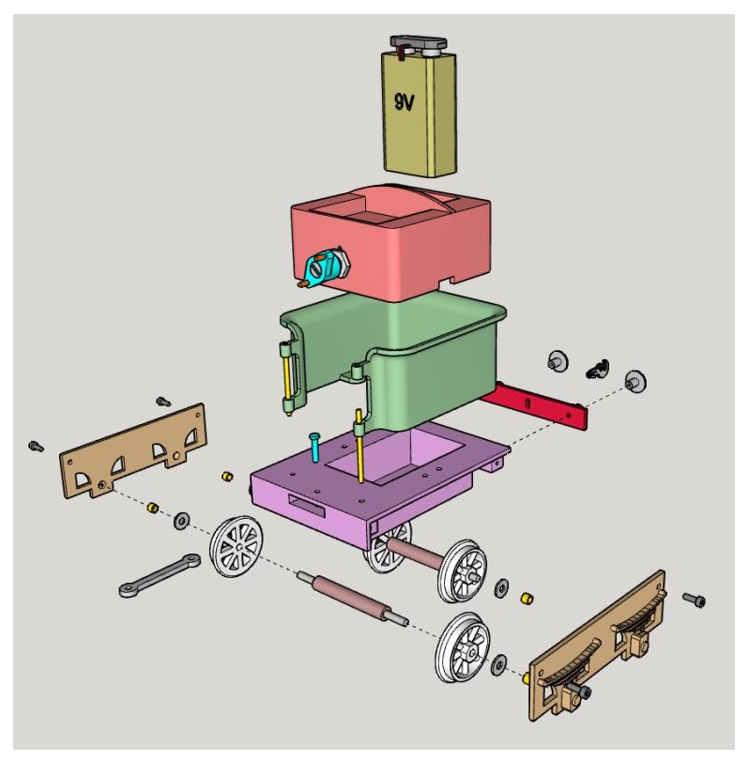

50.0 Side Frame: Fit axle bearings, , 4mm OD X .45mm wall X 3mm long brass tube.

51.0 Deck: Tap side holes M2.

52.0 Buffer Beam

53.0 Body: Tap mounting holes M2.

54.0 Wheel 24mm.

55.0 Axle: Fit with 3mm ground rod 62mm long then the wheels.

56.0 Hook

57.0 Buffer: Tap M2

58.0 Controls/Battery Box: tap mounting holes M2

59.0 Knob: Fit with bits of filament.

**Part 5, Coach.**

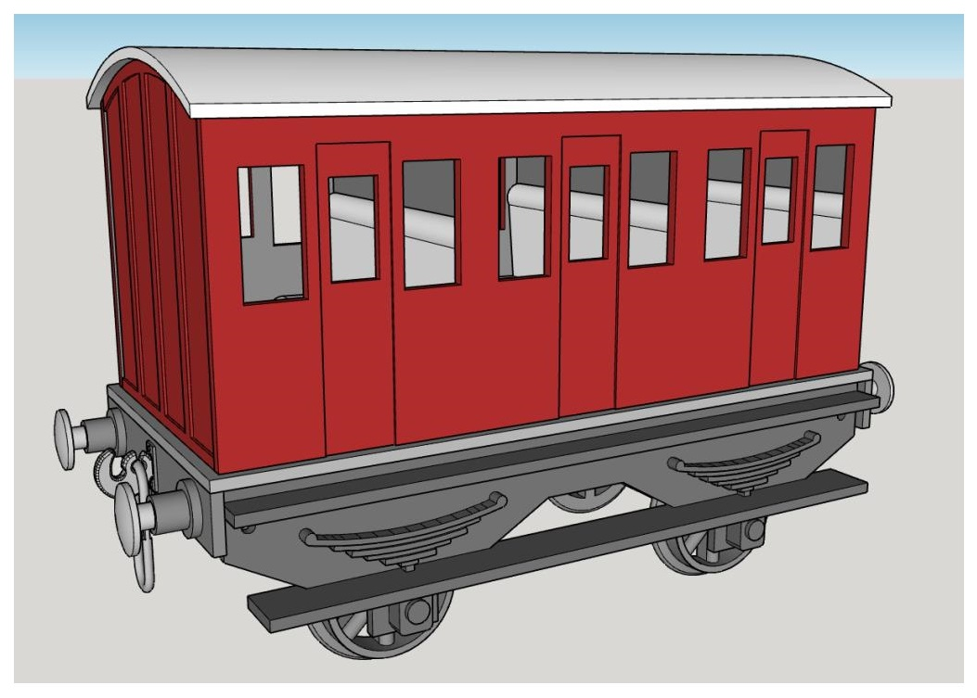

101.0 Side Frame: Fit axle bearings, 4mm OD X.45mm wall X 3mm long brass tube.

102.0 Buffer Beam

103.0 Buffer: Tap M2

104.0 Hook

104.0a Link: Note flats on one side to fit into hole on hook.

105.0 Floor: Tap side holes M2.

106.0 Body: Tap mounting holes M2.

107.0 Roof

108.0 Wheel 24mm.

109.0 Axle. Fit with 3mm ground rod 62mm long then the wheels.

110.0 Seats

