45’ GNR Bogie Coach Dia.129 and Dia.277 c. 1900
Peter F. Davis G1MRA #257 April 2026

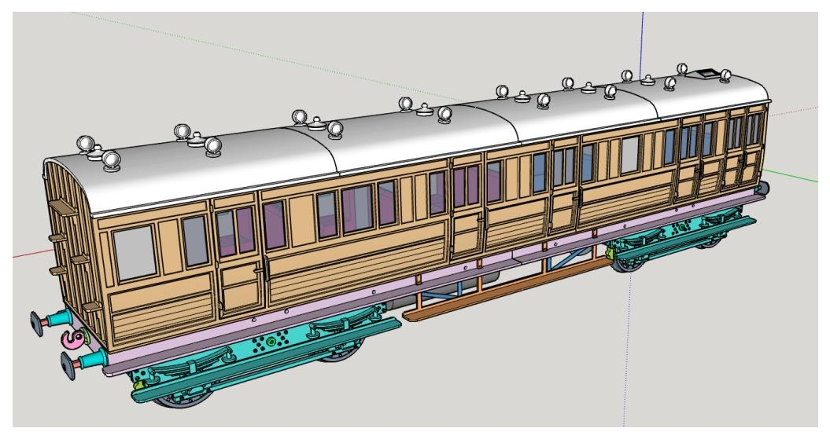

From drawings in Nick Camplings book “Historic Carriage Drawings”.

These are my notes and some suggestions.
The book has drawings for three GNR coaches that use this common frame. I chose to model two of the three.

Nozzle .4mm. Elegoo Neptune 3 Pro and Creality Ender 3 S1 filament printers used.

3/8” scale (9.5mm), printing with parts rotated 45 degrees on the build plate. This aligns the top layer with the panels.
I had good results using .1mm layers with .2mm initial layer. Printing most parts with 80 percent infill to add weight.
Body; Filament PLA “Overture” Matte Light Brown.
Roof, frame and trucks; black or gray PLA+, painting where necessary.

Purchased items and Some MSDS for Product used:
Cyanoacrylate Glue-Super Glue ( https://www.bsi-inc.com/sds_pdf/sds_insta_set.pdf )
Note of caution: Cyanoacrylate Glue (Super Glue). Young people and people unfamiliar with this product should seek knowledgeable adult supervision.
Un-Cure Cyanoacrylate Glue-Super Glue ( https://bsi-inc.com/sds_pdf/sds_un_cure.pdf ) Good to have on hand.
Permatex thread locker purple (https://www.permatex.com/wp-content/uploads/sds/24024.pdf )
Tamiya Putty white
G-S Hypo Cement. A clear cement for watch crystals.

Screws: 2mm x 8mm long = 11
2mm x 12mm long = 6
Nuts: 2mm = 14
4 Pieces 3mm dia. Ground SS rod x 62mm long.
8 Pieces K&S Brass tube 4mm OD x .45mm Wall x 5mm long

Chapter 1 Trucks
Holes for screws drill #46 or .081. Holes for 4mm bearings 5/32.
Wheels were drilled #32 or 3mm and assembled to axles with a bit of purple thread lock.
Assemble with screws snug, then back off screws just enough to leave the truck flexible. Use purple thread lock.
(Should you choose, optional truck sides without step are given)

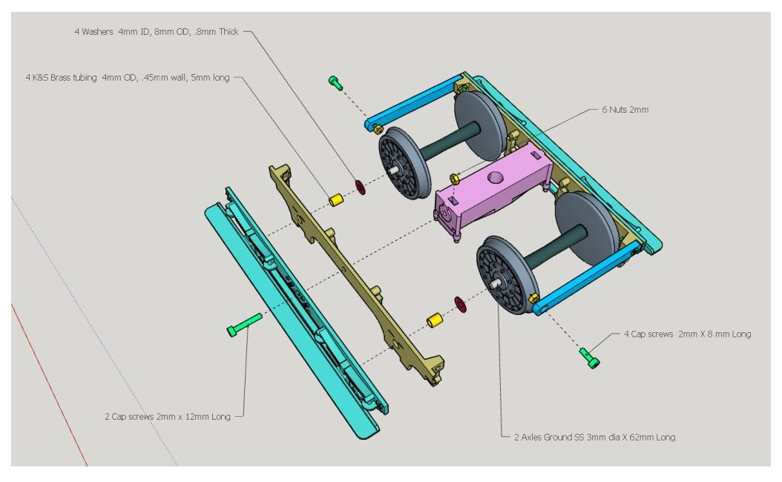
- 33.0 Wheel print 8
- 34.0 Truck side print 4
- 35.0 Bolster truck print 2
- 36.0 End Brace print 4
- 37.0 Truck retainer print 2
- 38.0 Axle print 4
Optional:
- 34.0 Truck side no step print 4 See view in Chapter 6 for reference.

Chapter 2 Frame

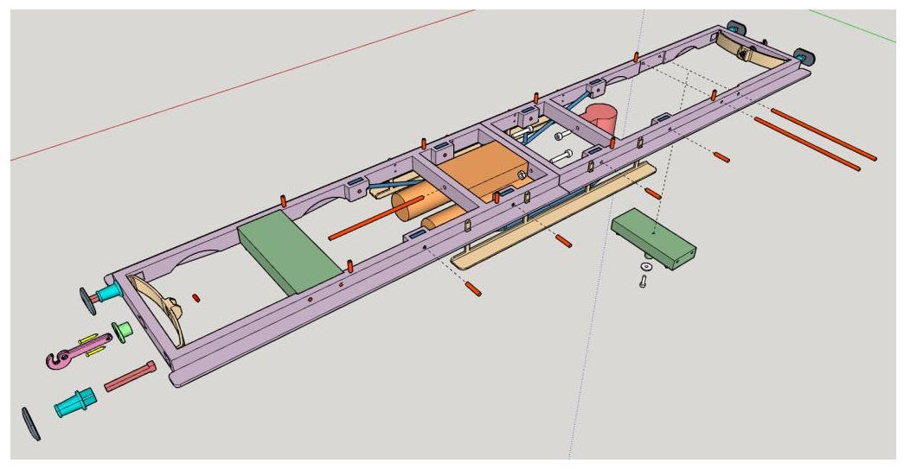
- Half-frame were printed diagonally on the hot plate. Assembled together with 2 bits of filament and screwed together.

- 41.0 Frame half print 2
- 42.0 Bolster frame print 2
- 43.0 Truss rod print 2
- 44.0 Step print 2 or Omit
- 45.0 Gas Cylinders print 1
- 46.0 Brake cylinder print 1

Chapter 3 Buffer/Coupler

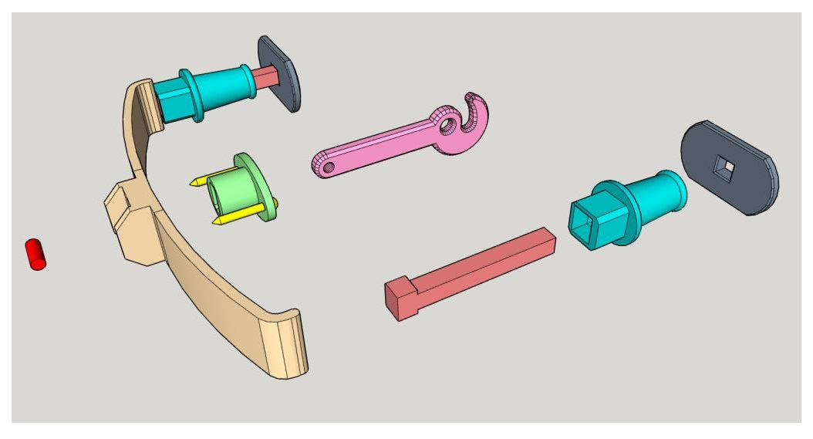
The buffer and shank may have to be fitted. I used a small square diamond coated file to fit the shank to buffer then glued the head onto the shank with a drop of super glue.
Purple thread lock used to attach the assembled buffer to the buffer beam.
- 51.0 Hook print 2
- 52.0 Hook Plate print 2
- 53.1 Hook Spring print 2
- 54.0 Buffer Head print 4
- 55.0 Buffer Head Shank print 4
- 56.0 Buffer print 4

Chapter 4 Body D129
The side/end pieces were printed with the inside surface down, rotated 45 degrees. Floor pieces also rotated 45 degrees.

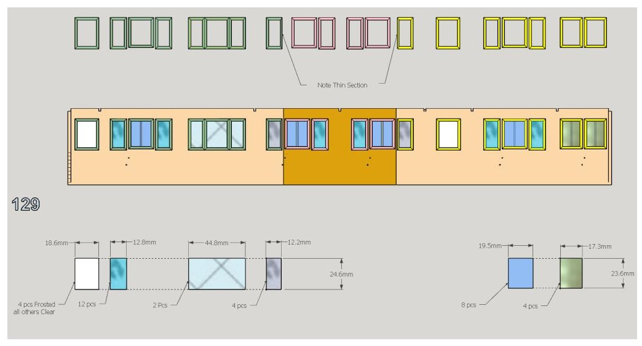

Window panes are .5mm thick, various widths and of 2 heights. Held in place by individual frames.

- 11.0 Window Frames Lav. End 6 piece set print 2 sets
- 12.0 Window Frames Center 4 piece set print 2 sets
- 13.0 Window Frames Lug. End 7 piece set print 2 sets

Install the window panes and frames.

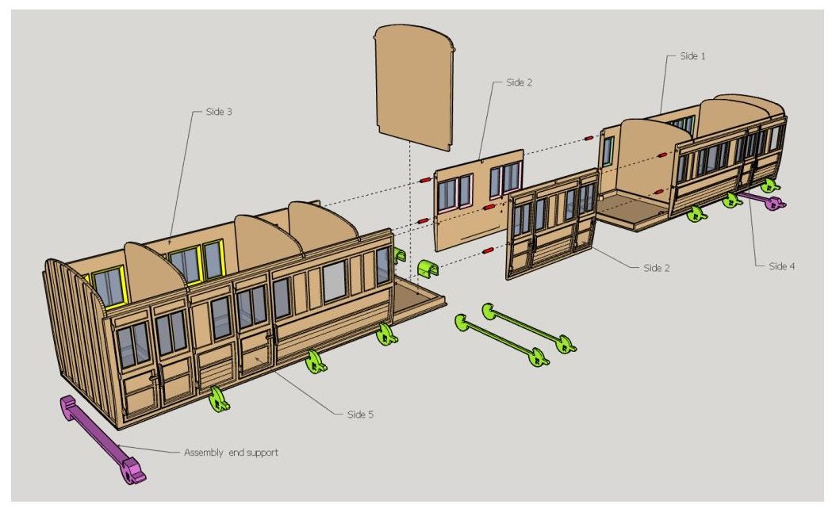
- Dry assemble the body on a flat surface. Inspecting as you go. Note the ends of the floor and sides are flush (as will be the roof).
- 8 printed clamps are used to hold the sides to the floor while gluing, 2 printed clips pull the two floor halves together while gluing.
- Use weights across the sides, holding the sides down to the floor piece. Move weights around to facilitate gluing if necessary.

- Note; the partitions are shorter than the 2 ends.

- Note of caution: Cyanoacrylate Glue (Super glue). Young people and people unfamiliar with this product should seek knowledgeable adult supervision.

- Gluing. I started in the 4 corners with a drop of super glue running down to the floor. Next, the same at the 4 side seams and on to the partitions. Also a drop at the floor for each side and partition.

- Remove the two clips, install and glue the center partition.

- 3.0 Side 1 print 1

- 4.0 Side 2c print 2

- 5.0 Side 3 print 1

- 6.0 Side 4 print 1

- 7.0 Side 5 print 1

- 8.0 End Lug. print 1

- 9.0 END Lav. print 1

- 10.0 Partition print 6

- 14.0 Floor Lav. end Print 1

- 15.0 Floor Lug. End print 1

- Assembly Clamp 72 print 8
- Assembly Clip print 2
- Assembly End Support print 2

4a Install Seats D129
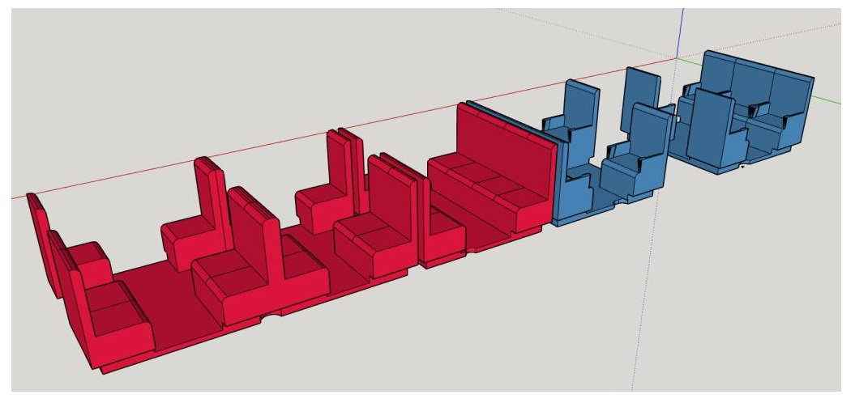
- 16.0 Seats First Class print 2

- 17.0 Seats Third Class open print 1

- 18.0 Seats third class print 1

Chapter 5 Roof D129

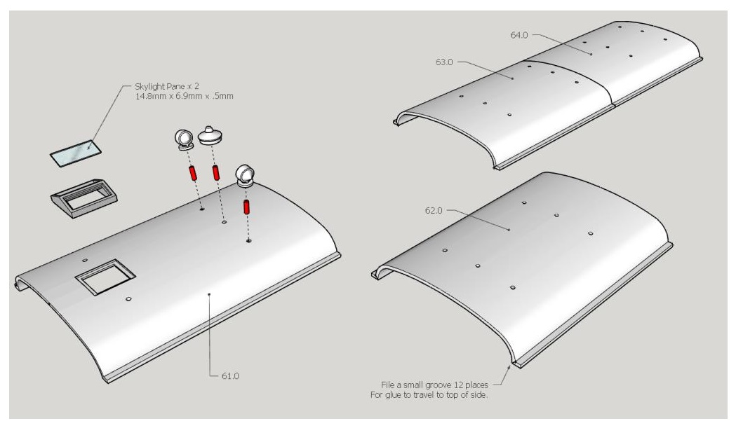
- I printed the roof sections vertically.
- Trial fit the roof pieces. Slide the end roof section back and fourth over the body ends, correct any interference.
- File small groove on the sections where they join, this will allow glue to travel inside when glueing the roof sections together.
- With the 4 roof sections in position on top the coach, start to glue at one of these grooves and draw a bead up to the top. Once the glue has dried, turn the assembly upside down glue the roof to the ends
- I used “Tamiya Putty” to correct any mismatch at the roof joints. Putty, sand, paint until the finish is acceptable to you.
- Add the sky light, lamps and torpedo vents. Final coat of roof paint.

- 61.0 Roof Lug. End print 1
- 62.0 Roof Center Lug. End print 1
- 63.0 Roof Center Lav. End print 1
- 64.0 Roof Lav. End Print 1
- 65.0 Sky light print 1
- 66.0 Lamp print 7
- 67.0 Torpedo Vent print 16

Chapter 6 Extra
Now the thought came to me, if one were to make a second lavatory end, to replace the luggage end, they could have a “Lav. All Third”. This may or may not have happened in real life, but will add variety to your train. Hypothetically of course, featured briefly and shown with no step.
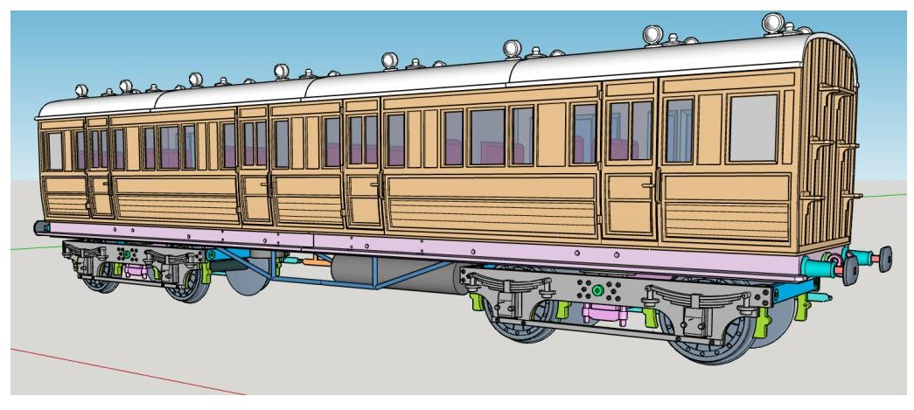
- 11.0 Window Frames Lav. End-6 piece set print 4 sets
- 12.0 Window Frames Center-4 piece set print 2 sets

- 3.0 Side 1 print 2
- 4.0 Side 2c print 2
- 6.0 Side 4 print 2
- 8.0 END Lug. print 1
- 9.0 END Lav. print 1

- 10.0 Partition print 6

- 14.0 Floor Lav. end Print 2

- Assembly Clamp 72 print 9
- Assembly Clip print 2
- Assembly End Support print 2

- 17.0 Seats Third Class open print 2
- 18.0 Seats third class print 2

- 63.0 Roof Center Lav. End print 2
- 64.0 Roof Lav. End Print 2
- 66.0 Lamp print 8
- 67.0 Torpedo Vent print 16

- Chapter 7 Brake 3rd Dia. 277

- 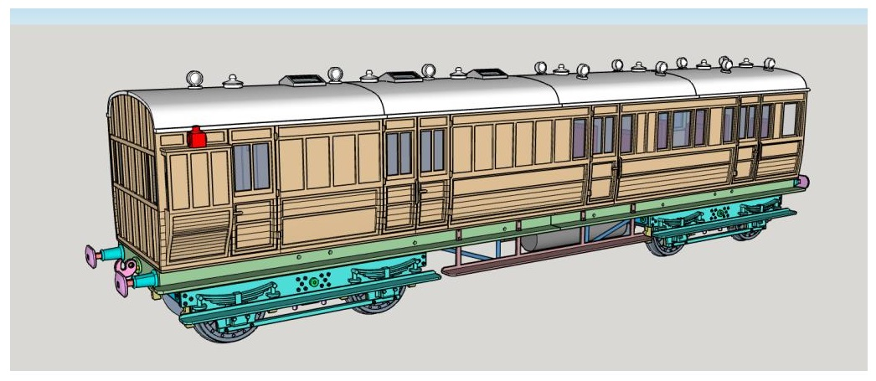

As with D-129, the side/end pieces were printed with the inside surface down, rotated 45 degrees. Floor pieces also printed, rotated 45 degrees.

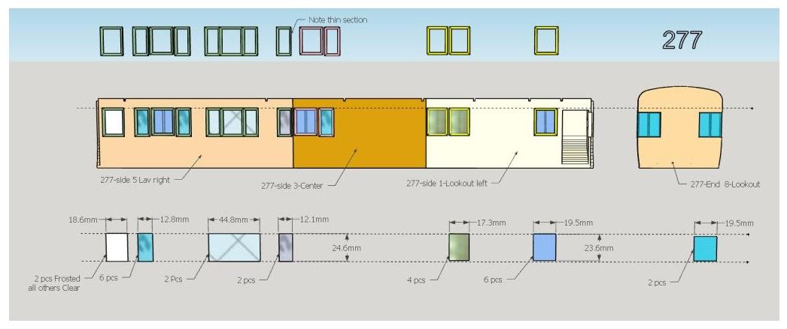

For the sides; window panes are various widths and of 2 heights. Held in place by individual frames.
The two panes for the end will require careful fitting. Here I used the watch crystal cement.
Panes are .5mm thick.

- Window frames Lav side 5-6, 6 piece set print 2 sets
- Window frames Center side 3-4, 2 piece set print 2 sets
- Window frames Lookout-side 1-2, 3 piece set print 2 sets
- No frames used for the two end panes.

Install the window panes and frames.

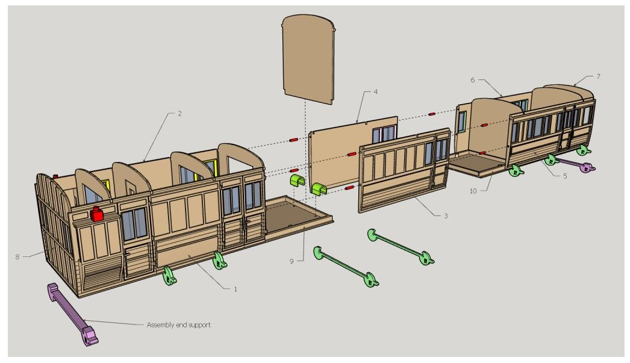

- Dry assemble the body on a flat surface. Inspecting as you go. Note the ends of the floor and sides are flush (as will be the roof).
- 7 printed clamps are used to hold the sides to the floor while gluing, 2 printed clips pull the two floor halves together while gluing. 2 printed end supports hold the sides in and support the floor from sagging under any added weight.
- Use weights across the sides, holding the sides down to the floor piece. Move weights around to facilitate gluing if necessary.

- Note; the partitions are shorter than the 2 ends.

- Note of caution: Cyanoacrylate Glue (Super glue). Young people and people unfamiliar with this product should seek knowledgeable adult supervision.

- Gluing. I started in the 4 corners with a drop of super glue running down to the floor. Next, the same at the 4 side seams and on to the partitions. Also a drop at the floor for each side and partition.

- Remove the two clips, install and glue the center partition.

277-1 Side 1-Lookout left
277-2 Side 2-Lookout Right
277-3 Side 3-Center
277-4 Side 4-Center
277-5 Side 5 Lav right
277-6 Side 6 Lav Left

277-7 End 7-Lav
277-8 End 8-Lookout

277-9-Floor Lookout end
277-10-Floor Lav end

277-11A Partition print 3
277-11B Partition print 1
277-11C Partition print 3

Assembly CLIP print 2
Assembly clamp 72 print 7
Assembly 72 End support print 2

7a Install Seats D277
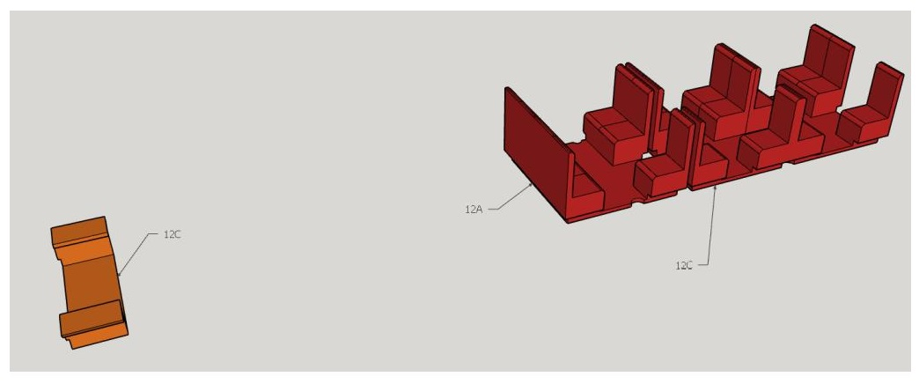

277-12A Seats
277-12B Seats
277-12C Seats Lookout

Chapter 8 Roof D277
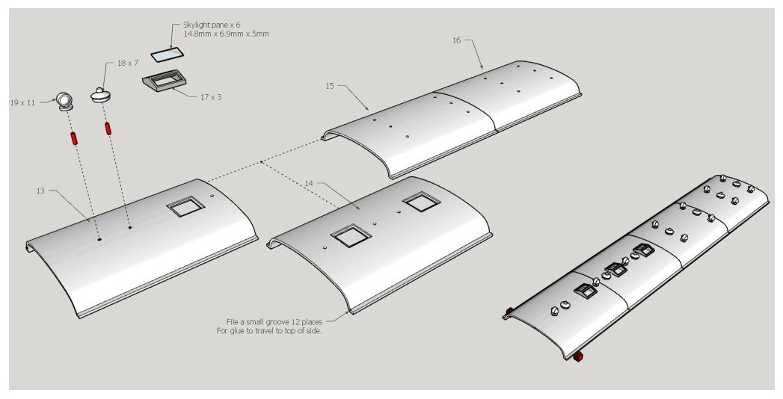

277-13 Roof-Lookout end
277-14 Roof-center Lookout end
277-15 Roof-Center lav. end
277-16 Roof-Lav. end

65.0 Skylight print 3
Skylight Panes 6 pieces 14.8mm x 6.9mm x .5mm clear
66.0 Lamp print 7
67.0 Torpedo Vent print 11

GN.200 Side Lamp print 2

Exploded view D277

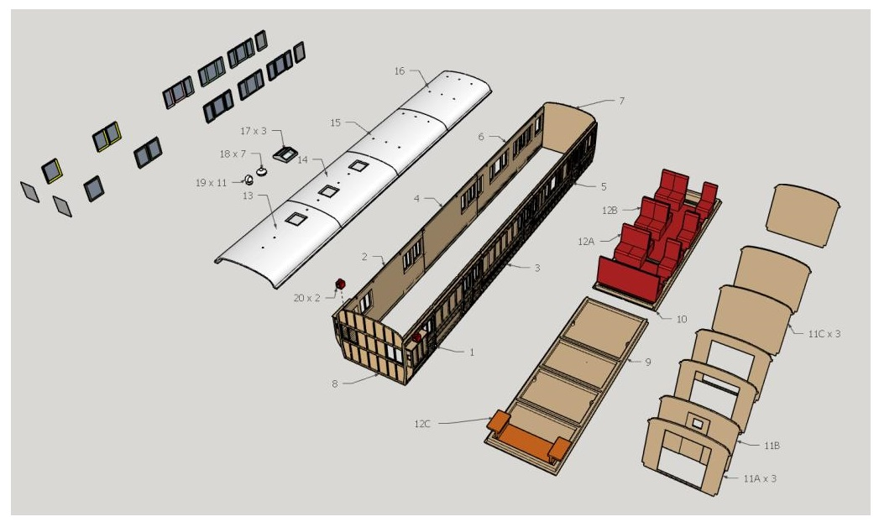

Peter F. Davis
G1MRA #257
17 April 2026

