Turnout 1800mm Radius 15°
Peter F. Davis #257 G1MRA June 2026

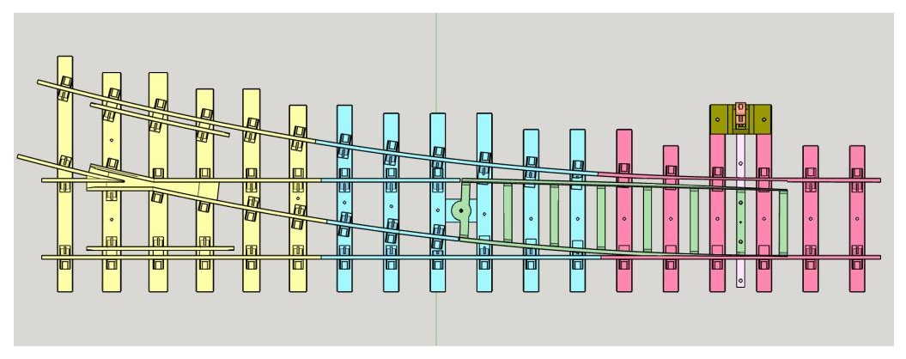

My plan was to design printable track system for indoor use. Basically to be on two 8’ x 2’ panels connected by a bridge with a point to point arrangement. Deciding a radius for the turnout, I printed some test track, straight and 1800mm radius curve to see if suitable. 1800mm (5.9’) was chosen to keep the turnout as short as posable. Turnouts take up a lot of space. My 08 shunter and Sentinel proved usable. For now, I have set up two 6’ tables with a connecting bridge for testing. Using three 16t mineral wagons, and GNR 4 wheel coach with NFS 5 plank wagon I can pull or push through successfully.

I used an Elegoo Neptune 3 Pro printer, “Duramic” PLA+ Brown filament, rotating the pieces 45 degrees to align the top finish with the ties.

*For a left turn out, flip the stl right to left before rotating and slicing. Parts 13, 23, 33 & 43

13 Frog
23 Center Drill and tap M2 for Point pivot screw
33 Front Drill and tap M2 two holes to mount throw housing.
43 Points Drill three holes 2mm

61 Throw Bar Drill and Tap M2 two holes for mounting to points.
62 Throw Housing Drill two mounting holes 2mm, pivot holes .07”and two spring holes 5/64”
63 Throw Lever Drill pivot hole .07”

912 RAIL JOINER 12mm
915 RAIL JOINER 15mm
91 8 RAIL JOINER 18mm

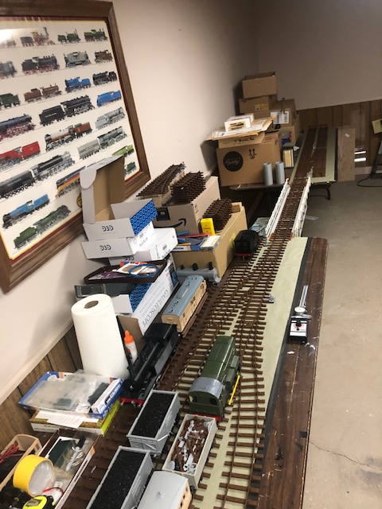

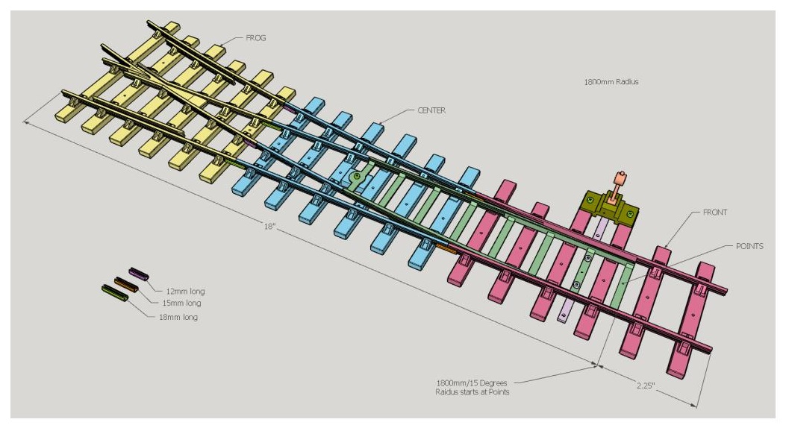

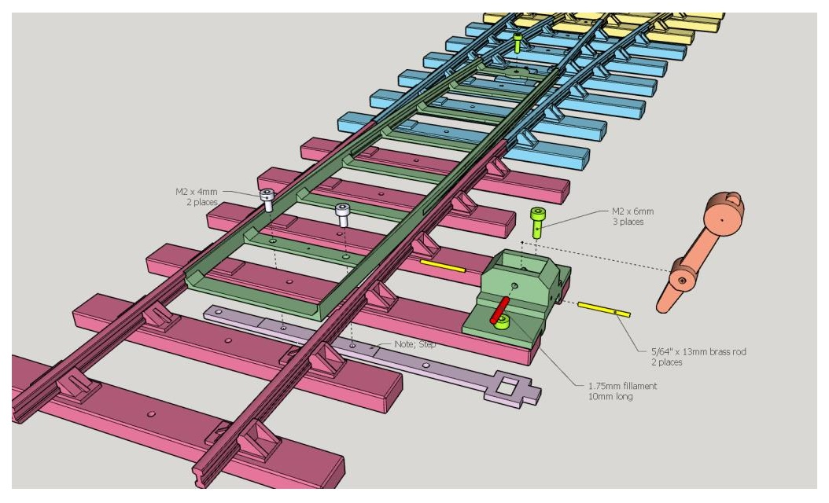

Additional track system Items:
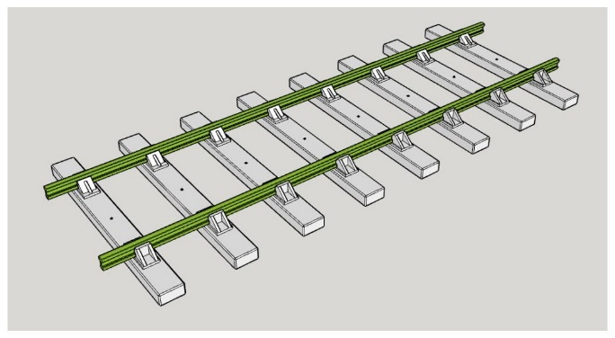
G1 Track Straight 9 in

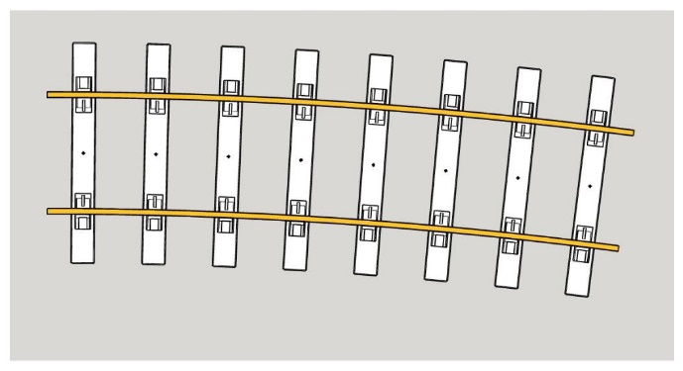
G1 Track curve 1800mm 7.5 degree

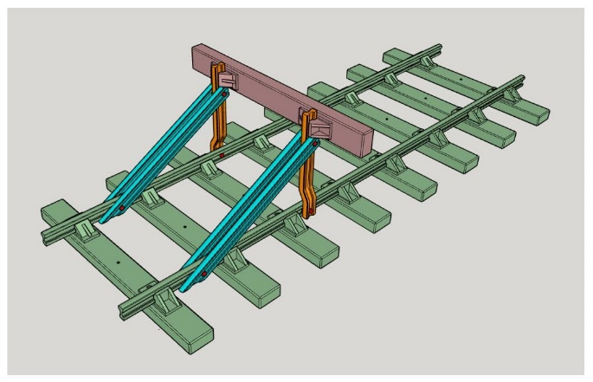
G1 Track End Stop

-0-

