Split version of David Viewing’s crown wheel and pinion gearbox
David Viewing’s gearbox, as used in the Greenly locomotive, is extremely useful to the gauge one community, being fully 3D printable. David’s models are mainly printed for him in SLS nylon which is quite a flexible material which makes the gearbox somewhat easier to assemble. Those of us who like to do our own 3D printing at home tend not to have our own SLS printers. Donald Picket redrew the gearbox into individual STLs for each component, which included such useful options as herringbone gear wheels and a thrust bearing recess for the crown wheel. The main gear casing is still the same as David’s, which means assembling the gear chain by pushing the axles through the complete gearbox casing. I find it difficult to do especially as the relatively thin inner bulkhead tends to break along the grain of an FDM print. I thought it would be easier to split the gearbox casing and screw it together with the gears in place. I also thought it would be useful to be able to remove the motor and pinion without dismantling the whole gearbox. The result is this gearbox which I think is easier and more satisfying to put together, while the significant number of metal screws must add to the adhesion weight of the loco! I have also rounded off some of the corners for ease of installation in the loco, while some of the wall thicknesses are greater in the hope of deadening some of the noise produced by the gears – I am not sure this has been effective. I have printed it in ABS on a Qidi Plus 4 core XY FDM printer, I am sure it should work on most printers.

3D Printed Parts required
Item | Identification
Gearbox casing left side. This can be identified by only five fastening screw holes, and the hole for the hall effect sensor (top left hand side in photo) | 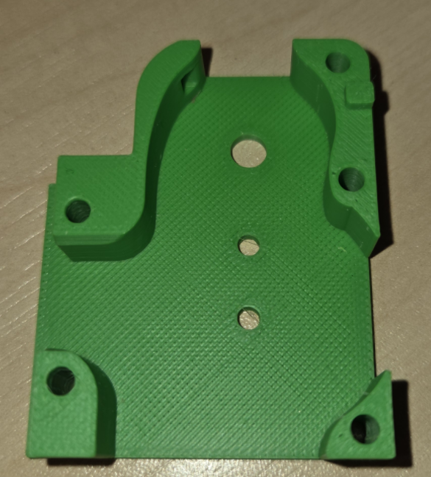
Gearbox casing right side. Shown here with the 3mm axles already installed. Note six screw holes. | 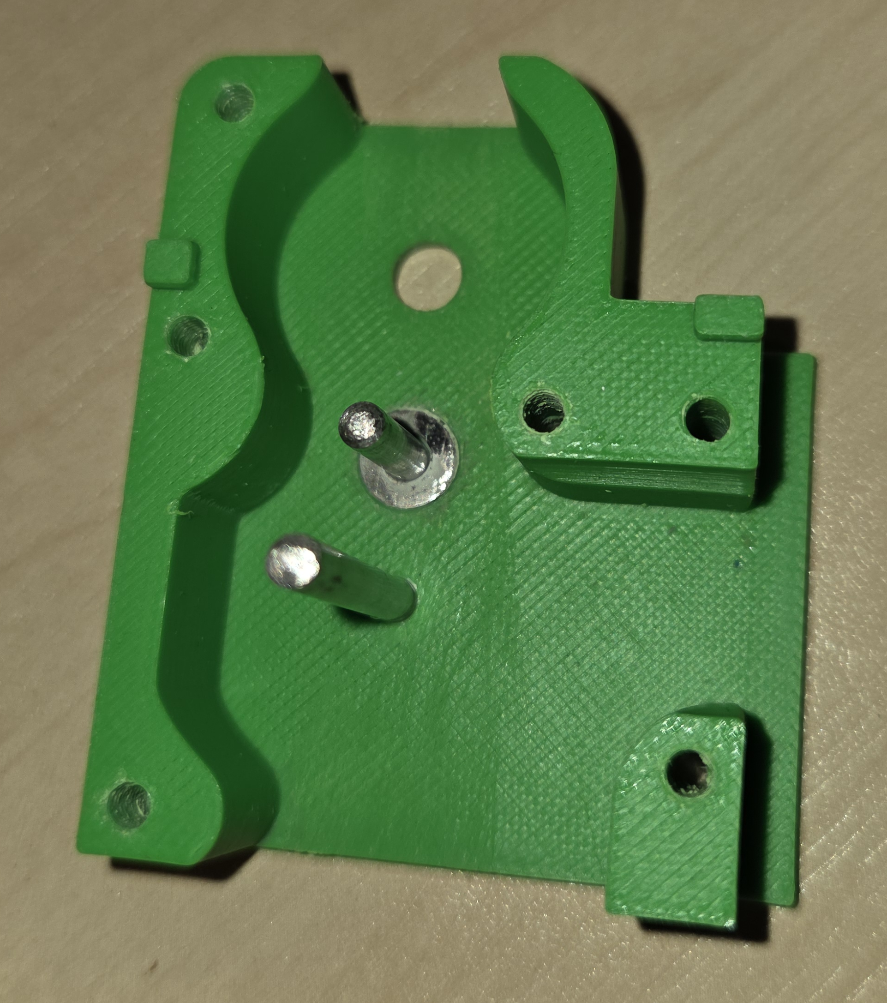
Gearbox casing central bulkhead | 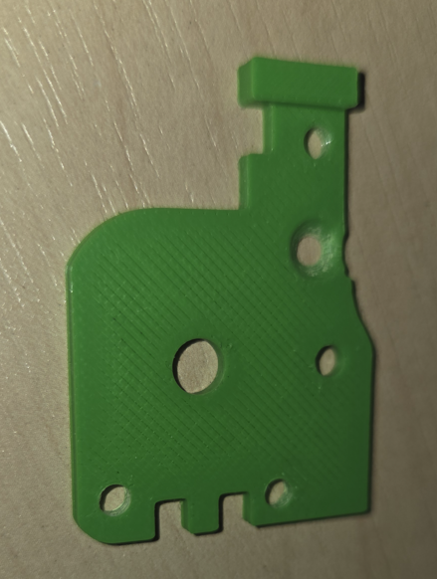
Motor mount | 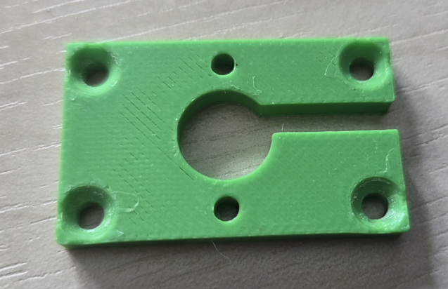
Output gear (fits 5mm axle shaft) | 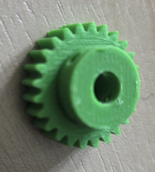
Idler gear (fits short 3mm axle) | 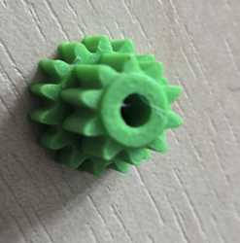
Crown wheel. Fits long 3mm axle | 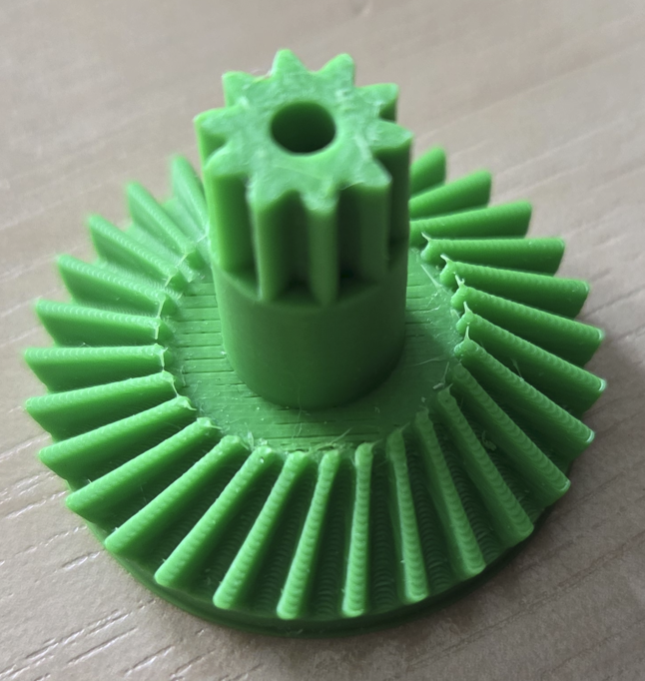
Magnet holder (for hall effect sensor) | 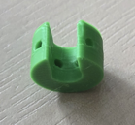
Motor pinion (shown attached to motor shaft) | 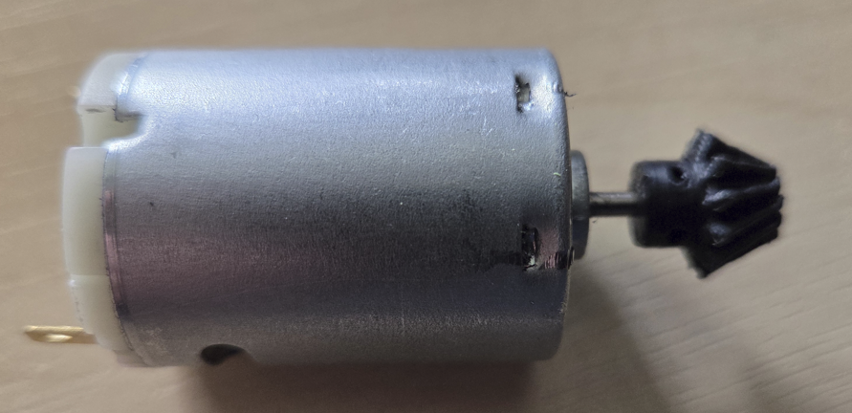
Other items
Item | Notes
5mm x 56mm axle shaft | Dimensions for Greenly loco – depending on wheel boss diameter there might be a slight difference in length.
3mm x 15mm axle shaft | For idler gear
3mm x 26mm axle shaft | For crown wheel
Thrust bearing 8mm OD 3mm ID | For fitting into recess on crown wheel. Note these come in three parts – two ball races and the central ball bearing holder
MABUCHI RS-385PH-2270 Carbon Brush Motor | Motor suitable for 6V – 24V
1 x M3 x 8mm countersunk machine screw | For securing inner bulkhead
5 x M3 x 20mm countersunk machine screw | For securing two halves of gear box together
2 x M2.5 6mm pan head cross head machine screws | For attaching the motor holder to the motor
Thin washers with hole size matching 3mm and 5mm | Helps space the gears in the gearbox to reduce binding with sides and to reduce sideways movement of gears on axles
4 x M3 x 12mm countersunk

Assembly The motor is screwed onto this using two M2.5 x 6mm pan head screws
Ream 5mm axle holes in left side, right side, and central bulkhead, so the axle turns freely.
Carefully ream the 3mm holes in the gear casing right side so the 3mm axles can be inserted with mild pressure. The gear wheels rotate on the stationary axles,so if the axles are too loose superglue them in position using the central bulkhead to ensure the idler gear (short) axle is perpendicular and the left side casing for ensuring the crown wheel (long 3mm) axle is perpendicular. You might choose to do this anyway to be sure. Just make use the superglue sparingly to keep it off the main part of the axle, and ensure the axles are perpendicular before the glue sets. No need to screw it together for this,
Carefully ream the 5mm hole in the output gear wheel so the axle can just be pressed on, preferably using a vice. If the hole is too large and the gear slips on the axle there is a staring hole for a grub screw. The gear needs to be off centre, with an 17.3mm gap between an axle end and the grub screw side of the gear wheel.
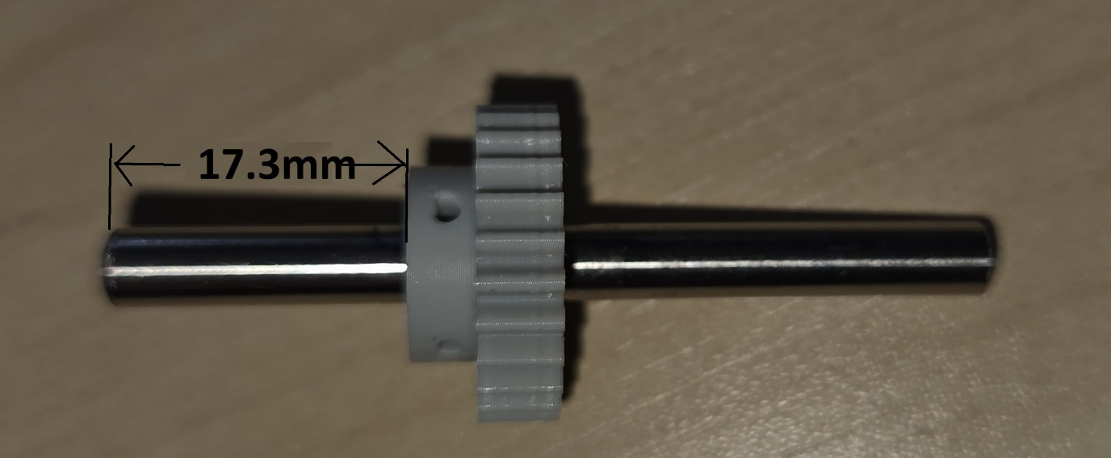
Assemble the idler gear and output gear. I used thin 5mm hole stainless washers to reduce side play on the axle, and a 3mm washer to ensure clearance for the idler gear.
These views show the orientation of the output and idler gears before the bulkhead is put in place, and what it looks like when the bulkhead has been secured with an M3 8mm countersunk machine screw.
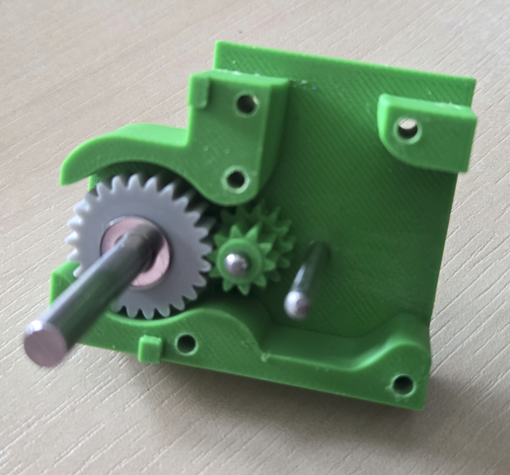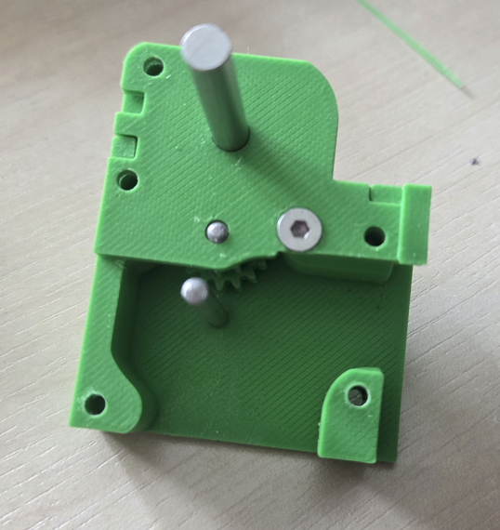
Ensure the thrust bearing recess in the crown wheel is cleaned up thoroughly. I used a milling cutter (hand held) to help with this. However you do it the thrust bearing parts need to fit snugly into the recess with only a small projection onto the flat side of the crown wheel.
Fit the crownwheel assembly with the small end first onto the long 3mm axle and fit the hall effect magnets onto the 5mm axle (it just pushes in from the side). You might want to fit the magnets first if they are to hand although it is possible to do it once the gearbox is assembled.
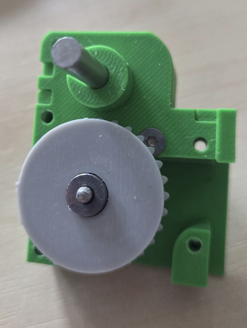
Now locate the left hand side casing onto the gearbox assembly and secure it using five 20mm M3 countersunk machine screws. The photo illustrates the gearbox at this stage, complete apart from the motor and its mount.
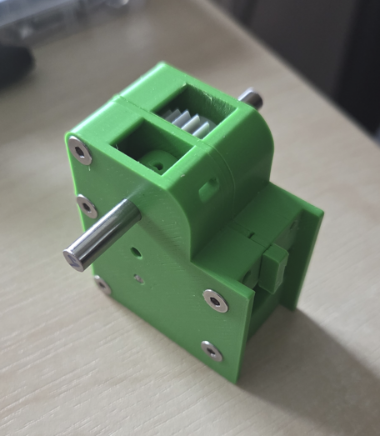
The motor is mounted onto a mounting plate which allows it to be removed from the gearbox without dismantling the whole gearbox. The mounting plate has a slot allowing the mounting plate to be removed without removing the motor pinion. Screw the motor to the mounting plate using two 2.5mm 6mm pan head screws. Remember the motor is on the side with the countersunk holes for the mounting plate. It is best to attach the mounting plate before fitting the pinion so the depth to insert the shaft can be judged by temporarily fitting the motor/mounting plate to the gearbox.
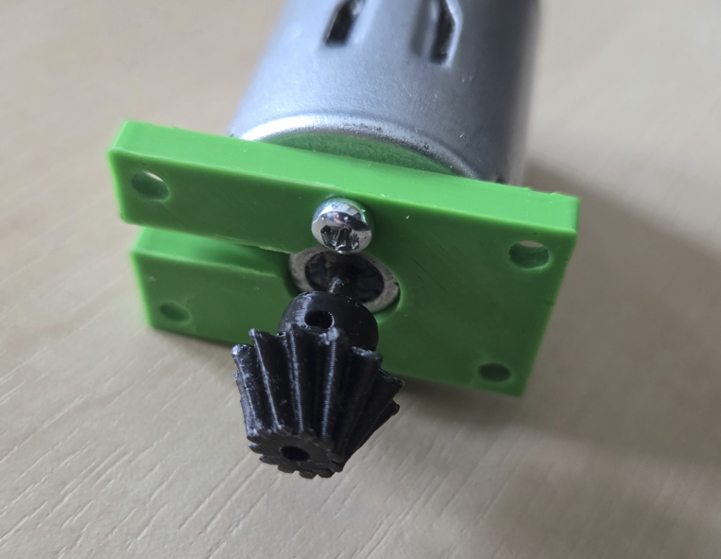
Clean the hole in the motor pinion but ensure it is a tight fit on the shaft. Force it in place making sure to support the other end of the shaft (which protrudes slightly from the motor) to avoid damage to the motor internals. The pinion should align with the crown wheel so test fit it in place as the pinion fit is carried out – it is easier to push the pinion further onto the shaft, difficult to pull it out.
Once satisfied the pinion is at the right dept screw the mounting plate in position using four M3x 12mm countersunk machine screws. The gearbox is now complete.

